**PROJECT REPORT**

**ON**

***“Fixitwala”***

**FOR**

**MES’s IMCC**

**BY**

**Rahul Kumar**

**SAVITRIBAI PHULE PUNE UNIVERSITY**

**MASTER IN COMPUTER APPLICATION**

**MAHARASHTRA EDUCATION SOCIETY’s**

**INSTITUTE OF MANAGEMENT AND CAREER COURSES**

**(IMCC), PUNE-411038**

**2023-24**

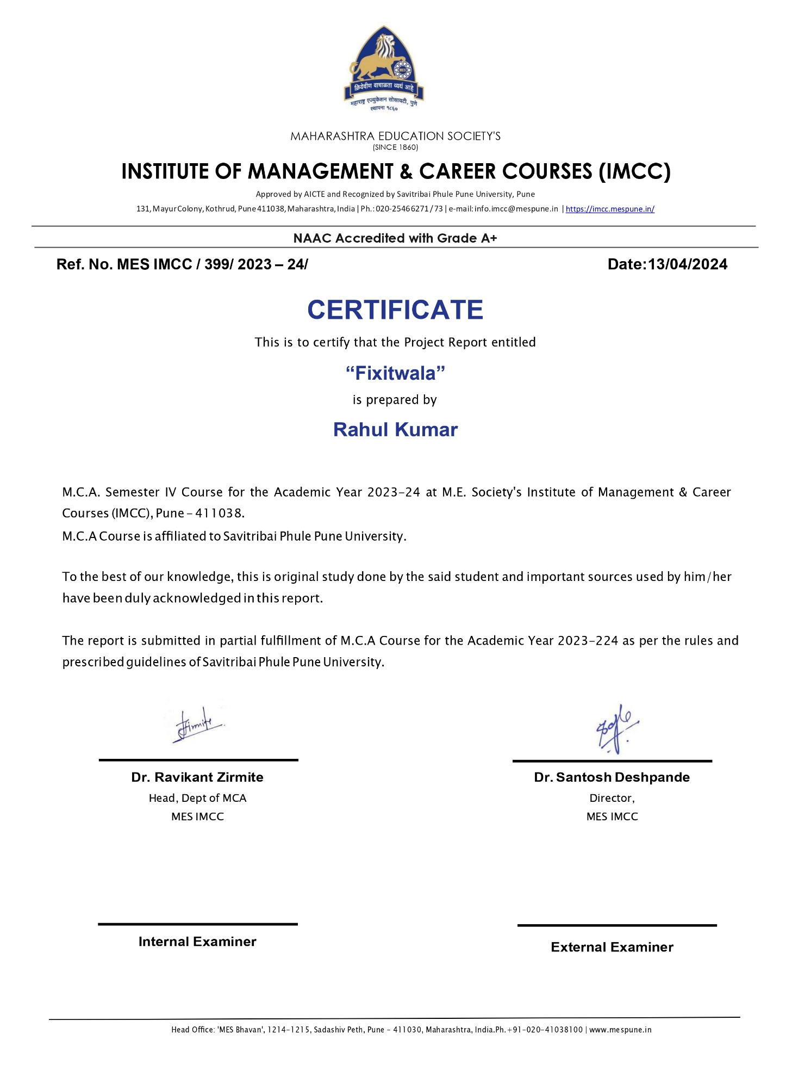

|  |
| --- |
| **CERTIFICATE**  This is to certify that the student Rahul Kumar has completed the project work entitled “Fixitwala” under my guidance. The report is submitted in partial fulfillment of M.C.A. Course for the Academic Year 2023-2024 as per the rules & prescribed guidelines of Savitribai Phule Pune University.  His work is found to be satisfactory and complete in all respects.  **Apurwa Barve**  **(Internal Project Guide)** |

**ACKNOWLEDGEMENT**

I would like to express my sincere gratitude to the following individuals for their invaluable support and guidance throughout the development of the social networking site project:

Director Sir: Dr. Santosh Deshpande, for his visionary leadership and continuous encouragement.

Deputy Director Ma'am: Dr. Manasi S. Bhate, for her unwavering support and insightful feedback.

HOD Sir: Dr. Ravikant Zirmite, for his guidance and expertise in the field of computer science.

External Project Guide: Mrs. Nivedita Mhaske, for his valuable inputs and suggestions that helped shape the project.

Internal Guide: Mrs. Apurwa Barve, for her mentorship and assistance at every stage of the project.

I would also like to thank my friends and family for their understanding and support during this project. Their encouragement kept me motivated to achieve my goals.

Lastly, I express my gratitude to the entire faculty and staff of MES’s IMCC for their support and cooperation.

Thank you.

Rahul Kumar

2201110  
SYMCA

**INDEX**

|  |  |  |  |
| --- | --- | --- | --- |
| Chapter No. |  | Details | Page No |
| **1** |  | **Introduction** |  |
|  | 1.1 | Institute Profile | 1-2 |
|  | 1.2 | Abstract | 3 |
|  | 1.3 | Existing System and Need for System | 4 |
|  | 1.4 | Scope of System | 5 |
|  | 1.5 | Operating Environment - Hardware and Software | 6-7 |
|  | 1.6 | Brief Description of Technology Used | 8-9 |
| **2** |  | **Proposed System** |  |
|  | 2.1 | Study of Similar Systems (If required research paper can be included) | 10 |
|  | 2.2 | Feasibility Study | 11-13 |
|  | 2.3 | Objectives of Proposed System | 14 |
|  | 2.4 | Users of System | 15-16 |
| **3** |  | **Analysis and Design** |  |
|  | 3.1 | System Requirements (Functional and Non-Functional requirements) | 17-19 |
|  | 3.2 | Entity Relationship Diagram (ERD) | 20 |
|  | 3.3 | Table Structure | 21-24 |
|  | 3.4 | Use Case Diagrams | 25 |
|  | 3.5 | Class Diagram | 26 |
|  | 3.6 | Activity Diagram | 27-30 |
|  | 3.7 | Deployment Diagram | 31 |
|  | 3.8 | Module Hierarchy Diagram | 32 |
|  | 3.9 | Sample Input and Output Screens | 33-41 |
| **4** |  | **Coding** |  |
|  | 4.1 | Algorithms | 42-47 |
|  | 4.2 | Code Snippets | 48-103 |
| **5** |  | **Testing** |  |
|  | 5.1 | Test Strategy | 104-107 |
|  | 5.2 | Unit Test Plan | 108-110 |
|  | 5.3 | Acceptance Test Plan | 111-112 |
|  | 5.4 | Test Case / Test Script | 113-116 |
|  | 5.5 | Defect report / Test Log | 117-118 |
| **6** |  | **Limitations of Proposed System** | 119-120 |
| **7** |  | **Proposed Enhancements** | 121-122 |
| **8** |  | **Conclusion** | 123 |
| **9** |  | **Bibliography** |  |
| **10** |  | **User Manual** |  |